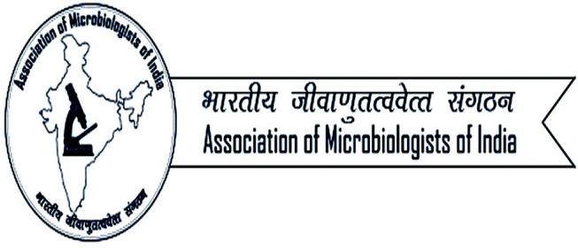

Call for ISME-AMI Early Career Travel Fellowship Award-2018
The award seeks the AMI Members (below the age of 35 years as on 31.10.2018) to attend the ISME-AMI session jointly organized by Association of Microbiologist of India (http://www.amiindia.info) and International Society for Microbial Ecology (https://www.isme-microbes.org/) at 59th Annual Conference of Association of Microbiologists of India & International Symposium on Host-Pathogen Interactions at University of Hyderabad, Telangana. Candidates can apply for the ISME-AMI Early Career Award. Award includes the train/air travel to 59th AMI conference at University of Hyderabad, Telangana by cheapest fare only.
Applicants can apply by filling the below given form (add extra sheets if necessary).

Last Name___________ Middle Name_____________ First Name__________

Date of Birth (With proof):

Title: Mr. Dr. Prof. Ms. Mrs.

Category 1. Student 2. Post doctorate 3. Faculty
Affiliation:

Supervisor details with address/email (if student or Post Doc.)

Complete address for correspondence

Valid Email Id:
Mobile Number:
Area of Specialization:

Publications with Impact Factor (only SCI journal):

Google scholar citations:

Q1. What according to you are the major steps need to be taken to promote Microbial Ecology in India. (300 words)

Q2. Your contributions to promote Microbial Ecology or Microbiology in India. (300 words)

*Applicant needs to send the above form along with their updated CV, list of publications in SCI journals and with their own or supervisor’s AMI Life Time Membership Number. The last date of submission of application is 15.11.2018 (by 5 PM). The applicant should be AMI Life Member or must join AMI membership immediately before applying for this award. The complete application should be sent to Email: gsami2014@gmail.com. Only electronic copy and applications received by deadline will be considered.
For any query please contact: General Secretary, Association of Microbiologists of India.
Email: gsami2014@gmail.com

